Just-Noticeable-difference (JND)
In general, images are nonstationary in nature, Human eyes demand different levels of fidelity for reconstructed images. Therefore, perceptual coding is essentially about adapting coding algorithms to the human eye's sensitivity. There have been several approaches to incorporating psychovisual properties of the human visual system (HVS) into algorithms for coding images. The HVS's sensitivity to spatial frequency has been exploited to adapt quantizer step size in frequency domain. Other efforts attempted to hide distortion in spatial domain by utilizing spatial masking effects. The nonlinearity of HVS and Insufficiency of quantitative measures for assessing image quality have prevented any image coding scheme from adequately integrating these psychovisual effects so that perceptual redundancies can be removed from still images in a simple and efficient manner [50], [51].
Recently, an important concept in perceptual coding was addressed in an article on image coding techniques: just-noticeable-difference (JND). As a result of the ideal JND, each signal can be encoded with a threshold level of error visibility, below which reconstruction errors disappear. JND profiles are determined by local signal attributes, like background intensity, luminance changes, and dominant spatial frequencies [51], [52]. These properties must be mapped to the JND using implemented perceptual models based on extensive subjective experiments. JND profiles can be used to quantify distortion energy and determine each signal's perceptual significance in an image. Thus, perceptually lossless coding requires an effective perceptual model capable of producing authentic JND profiles from input images [51].
To obtain the JND profile for grayscale images, a simple yet commonly used perceptual model is recommended. To minimize perceptual redundancy, a sub-band coding algorithm is devised. Visual thresholds play a crucial role in quantifying perceptual redundancy in image coding. In this context, visual thresholds refer to the magnitude of a stimulus at which it becomes partially visible or partially invisible. Several factors influence the visibility threshold of a specific stimulus. Regarding achromatic images in the spatial domain, two primary factors impact the error visibility threshold of each pixel. The first factor is the average luminance of the background behind the pixel being examined. The second factor is the spatial nonuniformity of the background luminance [50], [51].
Based on experiments examining the impact of the first factor, it has been found that human visual perception responds more strongly to differences in luminance contrast rather than absolute luminance levels. Weber's law suggests that if the luminance of a test stimulus becomes just noticeable compared to the surrounding luminance, the ratio between the noticeable luminance difference and the stimulus luminance remains relatively constant. Since the display is typically surrounded by ambient illumination, noise in very dark areas tends to be less noticeable compared to noise in areas with higher luminance. Consequently, when the background luminance is low, the Weber fraction (the noticeable difference relative to the stimulus) increases as the background luminance decreases. On the other hand, if the background luminance is high, the Weber fraction remains constant as the background luminance increases. This adjustment has been implemented in perceptually tuned image coders, where regions that are very dark or very bright have higher visibility thresholds, while medium grey levels around 127 have lower visibility thresholds [50]–[52].
Another factor is that the reduction in visibility is due to the increase in spatial nonuniformity of the background luminance. The spatial masking of this fact is referred to as spatial masking. The efficiency of coding has been improved with some forms of spatial masking. The masking effect is, however, a very intricate step, for which there is no single theoretical formulation that can fully explain its various manifestations. The spatial masking technique has been widely applied to optimize differential pulse-code modulation (DPCM) coders, where the quantizer is designed in such a way as to mask quantization errors by luminance transitions [50]–[52]. Visibility thresholds of luminance difference are often defined as functions of luminance edge amplitude, where perturbations are varied until they become just perceptible. An experimental result shows that luminance difference thresholds are related to luminance edge heights. The visibility threshold is also affected by the background luminance as well as the edge height. It can be seen that spatial activity masking functions are calculated by weighing the luminance slopes of neighboring pixels, with weight decreasing as distance between neighboring pixels and the central pixel increases. It is possible to determine the subjective magnitude of the test stimulus as a masking function exceeds a certain threshold using the noise visibility function. As a result of the experiments, high masking function values generally led to low visibility function values. Furthermore, these results confirm that noise visibility decreases near spatial details, and fewer pixels have high spatial details in most images [50], [51].
To assess the perceptual redundancies, present in an image, it is recommended to consider the characteristics of the Human Visual System (HVS) when estimating the Just Noticeable Difference (JND) profile. The visibility threshold of JND can be a complex function influenced by the two aforementioned factors in real-world images. The suggested model assumes that the primary influence of these two factors determines the JND value and simplifies their interdependence. These expressions describe the perceptual model that can be used to estimate a full-band JND profile [51].

${JND}_{fb}\left(x,y\right)=max\left\{f_{1}\left(bg\left(x,y\right),mg\left(x,y\right)\right),f_{2}\left(bg\left(x,y\right)\right)\right\}$
$f_{1}\left(bg\left(x,y\right),mg\left(x,y\right)\right)=$ $mg\left(x,y\right)α\left(bg\left(x,y\right)\right)+β\left(bg\left(x,y\right)\right)$
$$f_{2}\left(bg\left(x,y\right)\right)= \left\{\begin{aligned}{ T}_{0} . (1-{\left({bg\left(x,y\right)}/{127}\right)}^{1/2}))+3 for bg(x,y)≤127 \\ γ.\left(bg\left(x,y\right)-127\right)+3 for bg(x,y)>127 \end{aligned}\right.$$
$$α\left(bg\left(x,y\right)\right)= bg\left(x,y\right) . 0.0001+0.0115$$
$$β\left(bg\left(x,y\right)\right)= λ-bg\left(x,y\right). 0.01 for 0≤x < H , 0≤y< W$$
Where $bg(x,y)$ and $mg(z,y)$ represent the average background luminance and the maximum weighted average of luminance differences in the pixels around $(x,y).$The height and width of the image are denoted by H and W, respectively. The spatial masking effect can be modelled by function. According to Figure ‎2.5, the slope of the line relating visibility threshold to luminance difference tends to increase slightly with background luminance. The parameters$a(x,y)$and $β(x,y)$ specify the slope of the line and its intersection with the visibility threshold axis based on background luminance [51]. Using a subjective test, the visibility threshold due to background luminance is determined based on noise sensitivity. An experiment in which a square area of 32 x 32 pixels is located in the center of a flat field of constant grey level is conducted. Randomly adding or subtracting noises of fixed amplitude from pixels within the square area is performed for each possible gray level of the flat field. When the square region contaminated by the noises is barely visible, when the noise amplitude is varied, the visibility threshold for each grey level can be determined. The experimental outcome is very similar to the test results, as shown in Figure ‎2.5. In Figure ‎2.6 , the relationship for low background luminance (below 127) is modeled using a root equation, while the other part (above 127) is approximated by a linear function. In $f_{2} (x,y),$ $T_{0 }and γ$ and y represent, respectively, the visibility threshold at zero background gray level and the slope of a line that models the function at higher background luminance. As a result of spatial masking, the $λ$in $β(x,y)$ affects the average amplitude of visibility threshold. According to the experiments, the value of these three variables increases with increasing viewing distance. Therefore, the JND profile can be modeled as a monotonically increasing function of viewing distance. Based on the viewing distance used in the experiments,$T_{0 }, γ and λ$ are 17, 3/128, and 1/2, respectively [50]–[52].
A pixel's $mg(x,y)$ is determined by computing the weighted average of luminance changes around it in four directions. This can be seen in Figure ‎2.7, four operators, $G_{k}(i,j),$ for k = 1 to 4, and i, j= 1 to 5, calculate the weighting coefficient based on distance from central pixel, decreasing with distance [51].
$$mg\left(x,y\right)= \max_{k=1,2,3.4}\left\{\left|{grad}_{k}(x,y)\right|\right\}$$
$${grad}_{k}\left(x,y\right)= \frac{1}{16} \sum_{i=1}^{5}{\sum_{j=1}^{5}{p\left(x-3+i, y-3+j\right).G_{k}\left(i,j\right)}}$$
$$for 0≤x<H , 0≤Y<W$$
Where p(x,y) denotes the pixel at (x,y). An average background luminance, $bg(x,y),$ is calculated using a weighted lowpass operator, $B(i,j)$, where $i,j = 1 to 5$ , shown in Figure ‎2.8 .
$bg\left(x,y\right)= \frac{1}{32} \sum_{i=1}^{5}{\sum_{j=1}^{5}{p\left(x-3+i, y-3+j\right).B\left(i,j\right)}}$
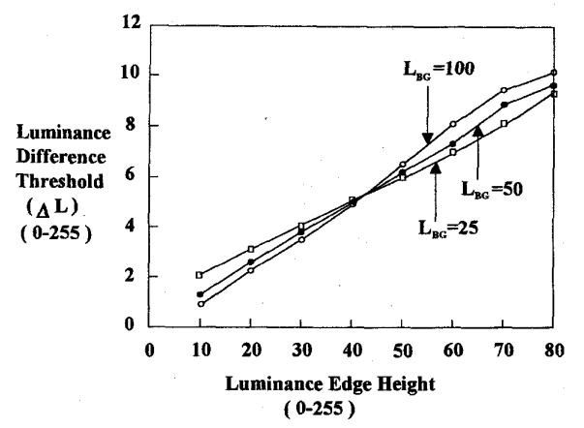
Figure ‎2.5 Difference visibility thresholds at different background luminance [51].
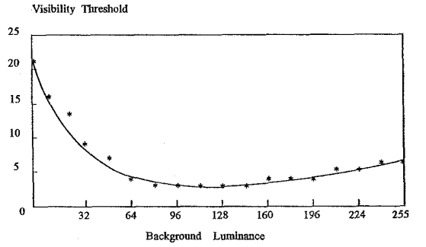
Figure ‎2.6 Visibility thresholds due to background luminance [51].

$$G_{1}$$ | $$G_{2}$$
  0 | 0 | 0 | 0 | 0
  1 | 3 | 8 | 3 | 1
  0 | 0 | 0 | 0 | 0
  -1 | -3 | -8 | -3 | -1
  0 | 0 | 0 | 0 | 0
  0 | 0 | 1 | 0 | 0
  0 | 8 | 3 | 0 | 0
  1 | 3 | 0 | -3 | -1
  0 | 0 | -3 | -8 | 0
  0 | 0 | -1 | 0 | 0
$$G_{3}$$ | $$G_{4}$$
  0 | 0 | 1 | 0 | 0
  0 | 0 | 3 | 8 | 0
  -1 | -3 | 0 | 3 | 1
  0 | -8 | -3 | 0 | 0
  0 | 0 | -1 | 0 | 0
  0 | 1 | 0 | -1 | 0
  0 | 3 | 0 | -3 | 0
  0 | 8 | 0 | -8 | 0
  0 | 3 | 0 | -3 | 0
  0 | 1 | 0 | -1 | 0
Figure ‎2.7 Operations for calculating the weighted average of luminance changes in four directions [51].

1 | 1 | 1 | 1 | 1
1 | 2 | 2 | 2 | 1
1 | 2 | 0 | 2 | 1
1 | 2 | 2 | 2 | 1
1 | 1 | 1 | 1 | 1
Figure ‎2.8 The operator for calculating the average background luminance [51].

References

[50] N. Jayant, J. Johnston, and R. Safranek, “Signal Compression Based on Models of Human Perception,” Proceedings of the IEEE, vol. 81, no. 10, 1993, doi: 10.1109/5.241504.
[51] C. H. Chou and Y. C. Li, “A Perceptually Tuned Subband Image Coder Based on the Measure of Just-Noticeable-Distortion Profile,” IEEE Transactions on Circuits and Systems for Video Technology, vol. 5, no. 6, 1995, doi: 10.1109/76.475889.
[52] H. Su, L. Yu, and C. Jung, “Joint Contrast Enhancement and Noise Reduction of Low Light Images Via JND Transform,” IEEE Trans Multimedia, vol. 24, 2022, doi: 10.1109/TMM.2020.3043106.

